**Review Berri-Renmark irrigation accession report and spreadsheet calculation**

11 August 2015

**The agreed tasks:**

1. Data reviewing included:
   * historical data on irrigated area,
   * irrigation application rates,
   * volume of irrigation water pumped,
   * volume of drainage water collected by the Comprehensive Drainage Scheme (CDS)
   * rainfall data
   * irrigation efficiency values used to estimate accessions to the original groundwater
2. Construct worksheets to estimate the volume of applied water draining beyond the rootzone of irrigated crops for each of the irrigation districts;
3. Provide the spreadsheet of interim estimations of accessions review by DEWNR groundwater modeller;
4. Provide the report of accession study.

The Berri- Renmark groundwater model covers the Central Irrigation Trust (CIT) areas of Cobdogla, Berri and Chaffey and the Renmark Irrigation Trust Area. Figure 1 shows the map of these irrigated districts.

Figure 1 needs replacing with new model project area as shown below

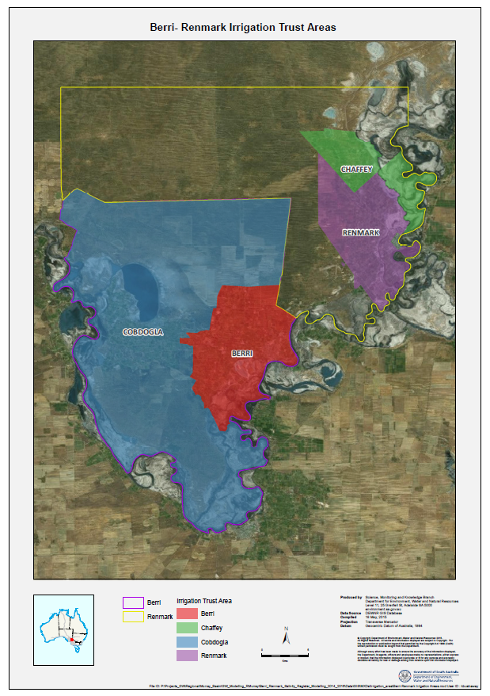

**DEWNR provided data:**

1. ***Berri-Renmark Consumption CropArea data 20150617.xlsx***

This is the first usage volume calculation.

1. ***Berri-Renmark Consumption data 20150708.xlsx***

This version updated to include trusts usage volume in 2005 – 2009. No usage information in Berri, Cobdogla and Renmark irrigation district from 1992–1994.

1. ***Berri-Renmark CropArea data 20150623.xlsx***

This version based on irrigation Cropdata (MSA) information and excluded Renmark irrigation area in 2004 and 2005 due to no data available.

**Section 2.2 Irrigation Application Volumes**

Records of pumped volumes for the period 1992 - 2013 for each of the irrigation districts were supplied in the file *Berri-Renmark Consumption data 20150617.xlsx*.

It should be the latest file provided *Berri-Renmark Consumption data 20150708.xlsx* for the period 1992-2014.

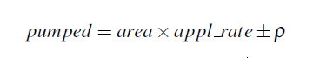

pumped is measured or estimated water volume applied (ML/ha),

area was either measured or estimated irrigated area,

appl_rate was inferred or measured application rate (ML/ha) and

is a random component to mimic variability.

**Section 2.3 Application rate**

|  |  |
| --- | --- |
| **Year** | **Application rate (ML/ha)** |
| Before 1931 | 11 |
| 1932-1970 | 10.5 |
| 1971-1991 | 9.5 |
| 1992 onward | Measured data |

*appl_rate = pumped/irri_area*

appl_rate rate of application of irrigation water (ML/ha),

pumped is measured or estimated water volume applied (ML/ha) and

irr_area was either measured or estimated irrigated area (ha).

**Section 2.4 Irrigation Efficiency**

Irrigation efficiency values are based on Loxton-Bookpurnong Report (Meissner, 2011a).

|  |  |
| --- | --- |
| **Year** | **Irrigation Efficiency** |
| Before 1940 | 55 % |
| 1941 - 1960 | 60 % |
| 1961 - 1990 | 65 % |
| 1991 - 1994 | 70 % |
| 1996 - 2000 | 75 % |
| 2001 onward | 80 % |

**Section 2.5 Rainfall**

*Rain Volume = Rain (mm) x area/100*

Where 100 is the conversion constant from mm to ML

**Section 3 Assumption in estimating irrigation efficiency and application rate**

Two quantities were estimated:

* Application rate in units of ML/ha
* Irrigation efficiency a dimensionless quantity between 0 and 100%

**Section 3.1 Floodplain and highland**

As it is clearly stated that Renmark irrigation

Estimates of irrigation accessions made no distinction of topography because the information provided did not differentiate between floodplain and highland.

Would it be possible to distinguish irrigation accession volume from topography if irrigation trust area is separated into highland and floodplain?

How long will it take to repeat the process?

**Section 3.2 Comprehensive drainage schemes**

Renmark irrigation trust provided records of hours drainage pumps were run and the power used for the period October 1998 – May 2015 from 13 caissons.

**Section 3.3 Miscellaneous quantities**

The values for spillage (5% of pumped volumes) and transmission losses (15% of pumped volumes) were adopted.

The losses were eliminated once the districts replaced the concrete channels with pipes from the 1980s.

*Spreadsheet calculation*

Cobdogla used 10% transmission losses prior to 1975 and 6% transmission losses from 1976–2000.

Cobdogla used 5 % spillage before 1976 and 2.5 % from 1976-2000.

Berri used 5 % spillage and 10 % transmission losses throughout.

Renmark used 5 % spillage until 1932 and from 1933 used 1% spillage.

Transmission losses used 10% throughout.

Chaffey used 5 % spillage and 10 % transmission losses throughout.

Could you please give explanation of the difference between reported number and actual number used in the calculation? Cobdogla seems to have different values for different years, are there more information that we need to be aware of? The values of transmission losses between 10% and 15 % yield slightly different results for accession volume (ML), total application (ML/Ha), accession (ML/Ha) etc.

**Section 4 Calculation of Accession Volume**

60% of rainfall is considered being effectively applied to crops for the Riverland.

The volume draining past the root zone was estimated as:

*Accession volume = tot_appl x (1-IE)*

Where IE is irrigation efficiency,

Tot_appl is total application volume including rainfall, spillage and transmission losses.

**Section 5 Discussion**

The accession rates (ML/ha) for the four irrigation districts have similar trend and differ only in the simulated annual variation. Where measured data was available from 1992 onwards, there is little variation between the districts.

Overall, the report Estimation of Irrigation Accession Volumes for the Berri, Cobdogla, Renmark and Chaffey Irrigation Districts is succinct and well-constructed.

The spreadsheet calculation is easy to understand, the assumptions and method are appropriate and fit for the purpose of estimating irrigation accession volumes.